10/22/2026
LAB NO 07
Operating System Lab
Instructor: Ms. Muneeba Banaras
Submitted By: Wasif Ali
Reg ID: 245187
Class: BSCS F’24 B

LAB TASK
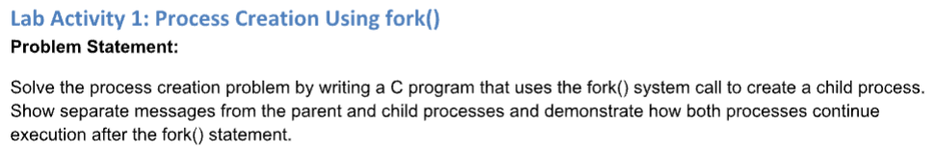
Code/Commands:
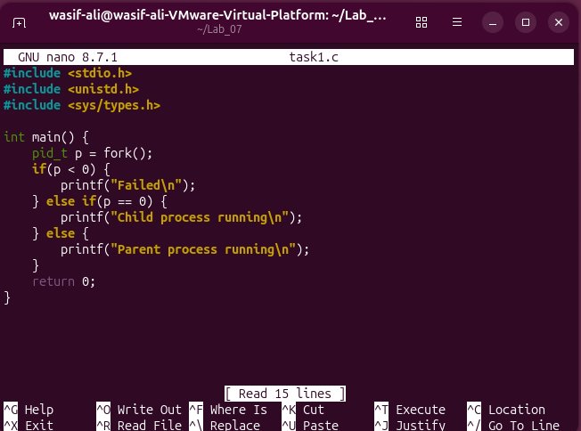
In this activity, we used the fork() function to create a new child process. We wrote a C program that prints separate messages to show that both the parent and the newly created child processes execute at the same time.

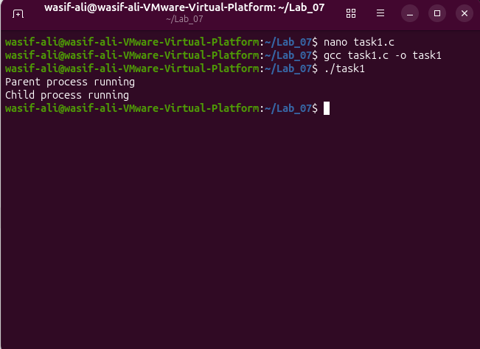
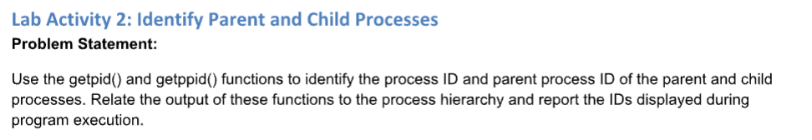
Code/Commands:
Here, we used the getpid() and getppid() functions to identify our processes. This allowed us to find and display the unique Process ID (PID) of the current process, as well as the PID of its parent process.
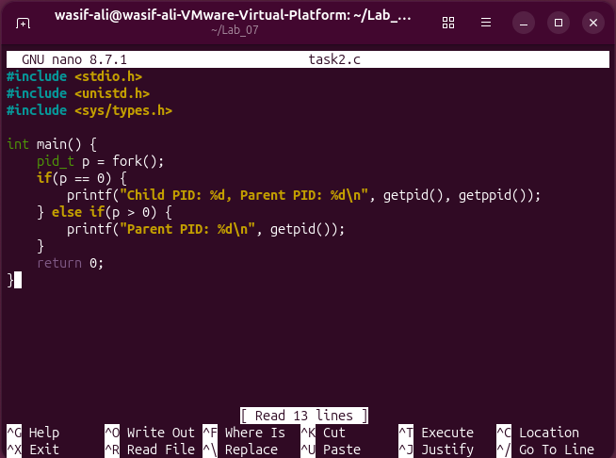

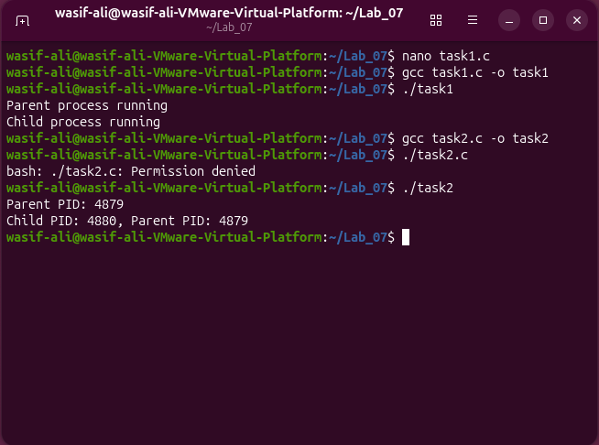

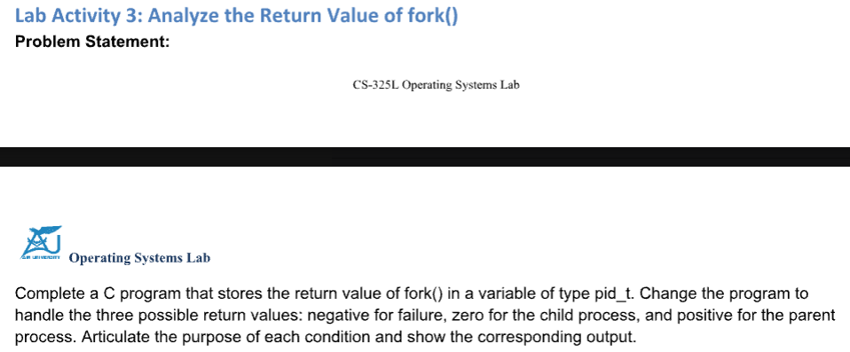
Code/Commands:
In this task, we checked the number returned by the fork() function. We used if-else conditions to print different messages based on whether the return value was negative (process creation failed), zero (we are in the child process), or positive (we are in the parent process).
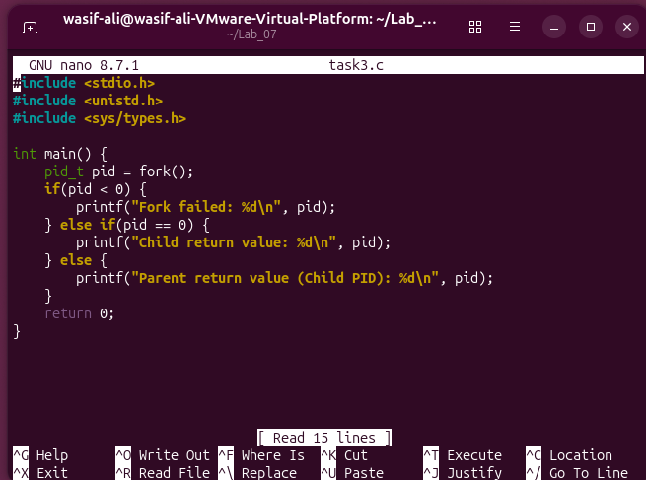
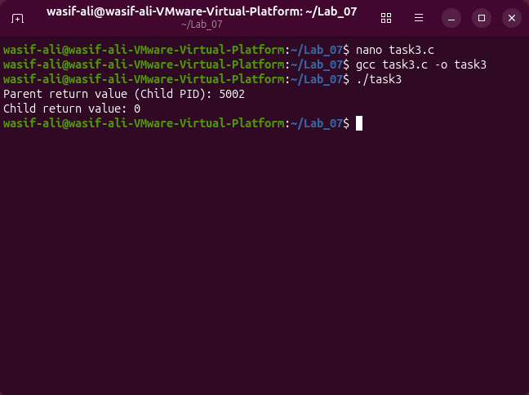

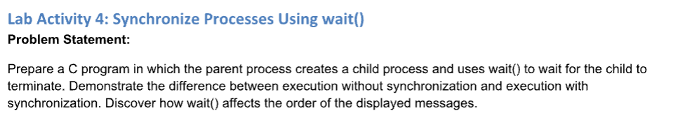
Code/Commands:
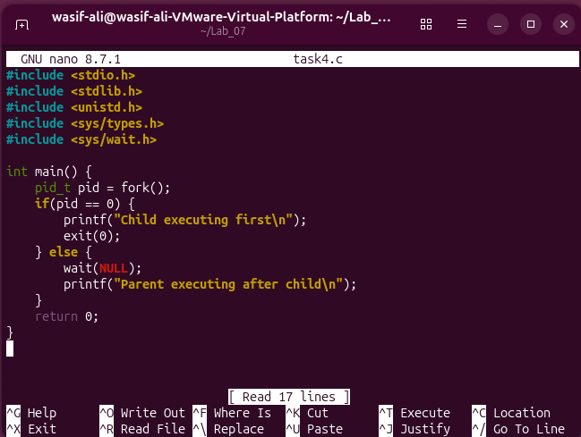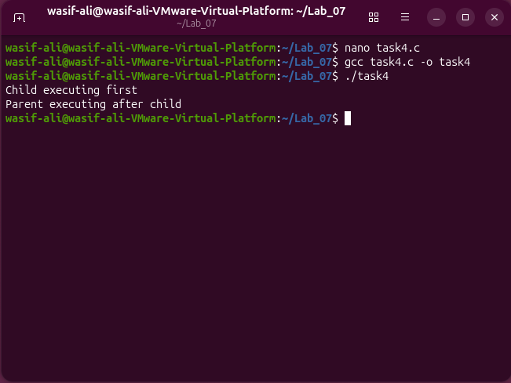
We learned how to synchronize processes using the wait() function. We made the parent process pause and wait for the child process to finish its execution completely before the parent continued with its own remaining code.
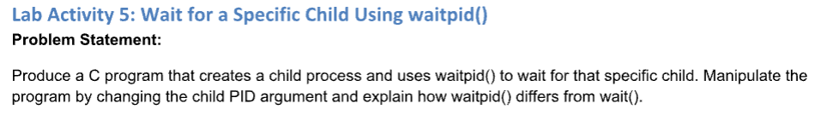
Code/Commands:
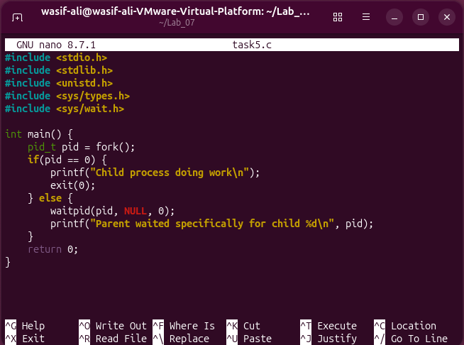
Building on the previous task, we used the waitpid() function instead of standard wait(). This gave us more control, allowing the parent process to wait for a specific child process to finish by targeting its exact Process ID.
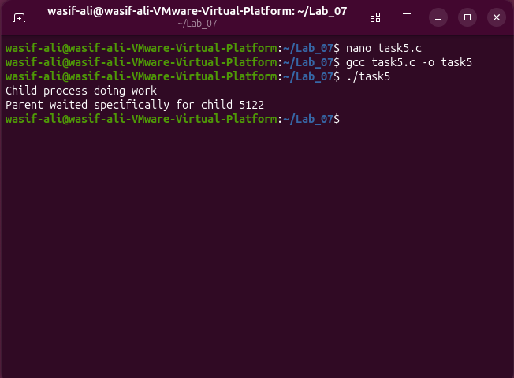

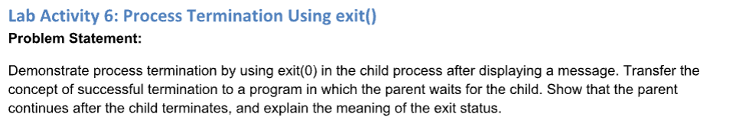
Code/Commands:
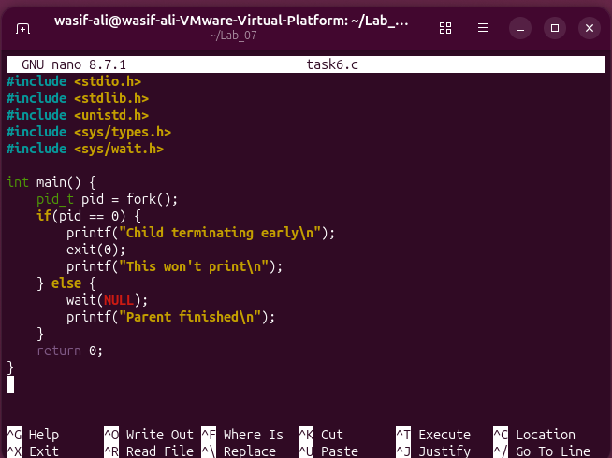
In this activity, we used the exit(0) function to safely terminate the child process. We demonstrated that when a process calls exit(), it stops immediately, and any lines of code written after the exit() command do not get executed.
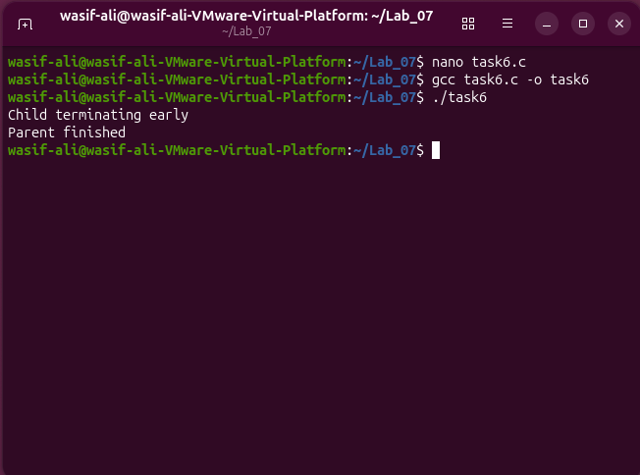

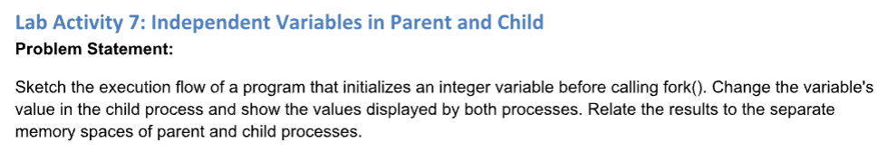
Code/Commands:
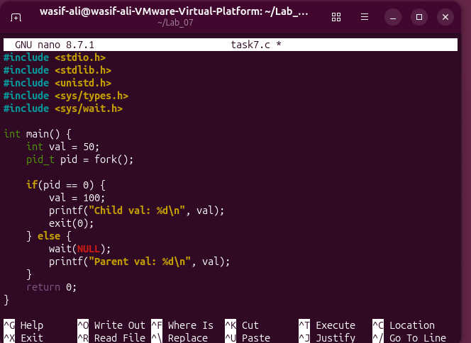
In the final task, we proved that parent and child processes have their own separate memory spaces. We changed the value of a variable inside the child process and saw that the parent's copy of that same variable remained completely unchanged.
